
Army Public College
Chinar Campus Murree
SAMPLE PAPER – ENTRY TEST
Paper: English MARKS: 25
Class: K.G Time: 30 Minutes

Q. 1. Trace the letter. [ /5]

Q. 2. Match the letters same letter. [ /5]
G h

H j

I k

J h

K g

Q. 3. Write a to e [ /5]

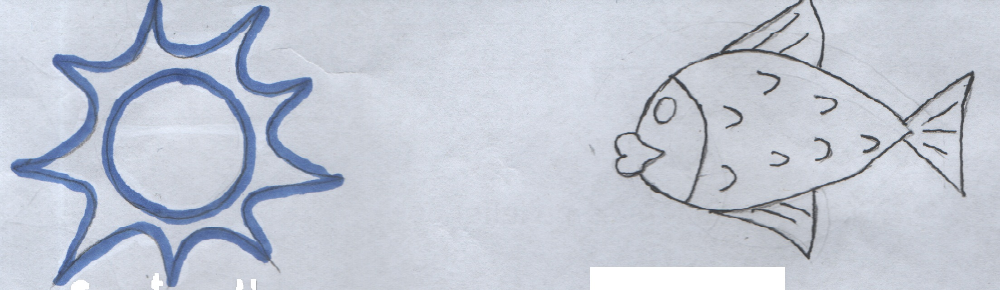
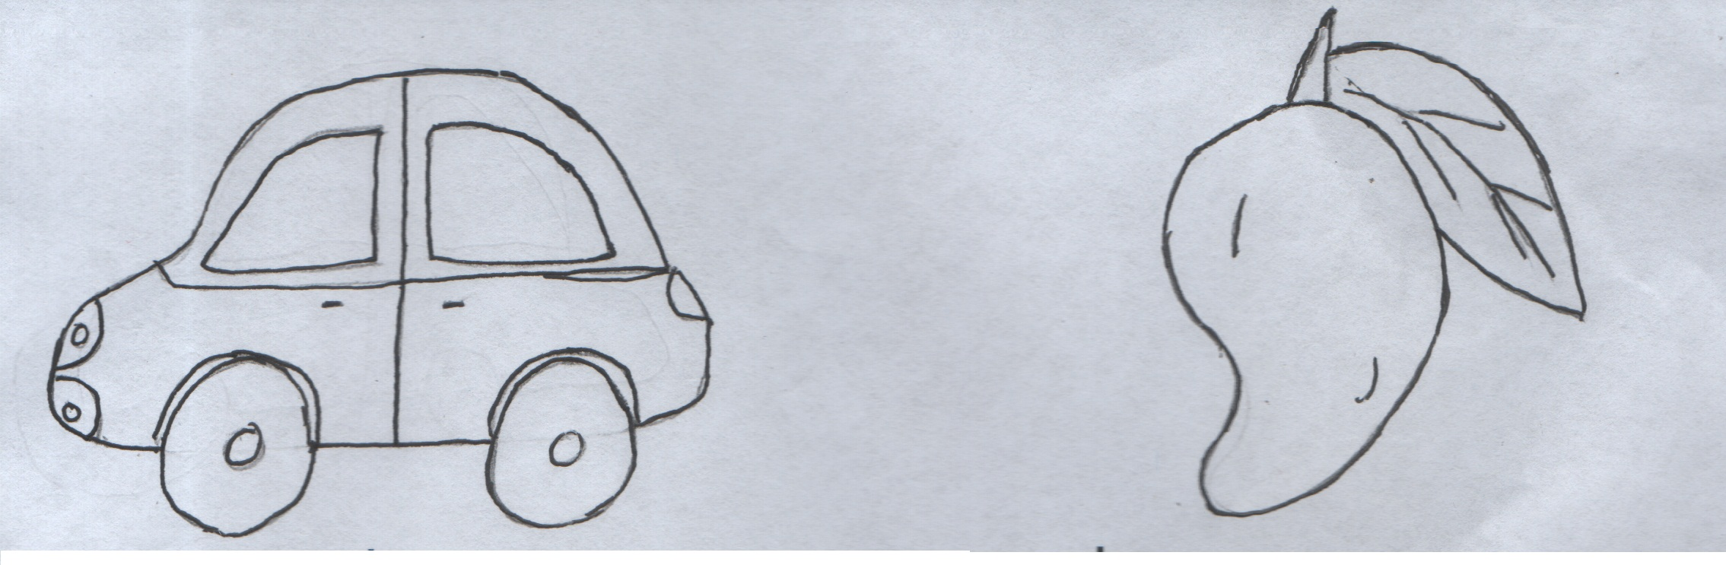
Q. 4. Circle the correct sound. [ /5] s t u t h f
c d e l m n
Q. 5. Read the alphabets. [ /2.5]
b z l q f
Q. 6. Rhyme singing. [ /2.5]
Army Public College
Chinar Campus Murree
SAMPLE PAPER – ENTRY TEST
Paper: Maths MARKS: 25
Class: K.G Time: 30 Minutes

Q. 1. Write numbers 1 – 5 [ /5]
. | . | . | . | .
Q. 2. Count and Match with correct number. [ /5]
3

4

5

6

8

Q. 3. Recognize the given shapes [ /5]

Q. 4. Circle the basket with more apples. [ /2.5]
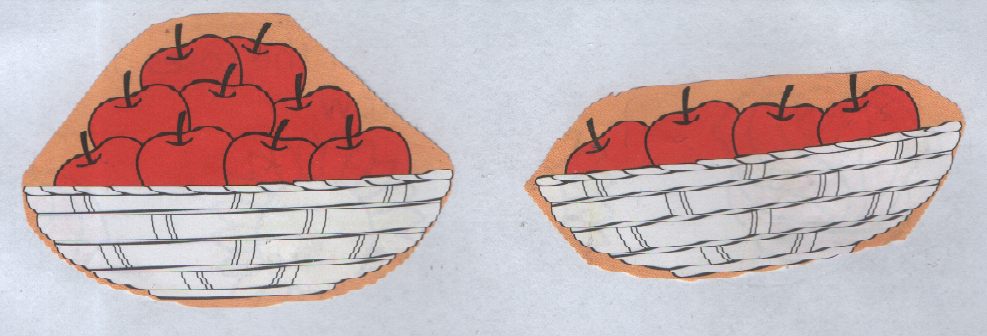
Q. 5. Circle the basket with less mangoes. [ /2.5]
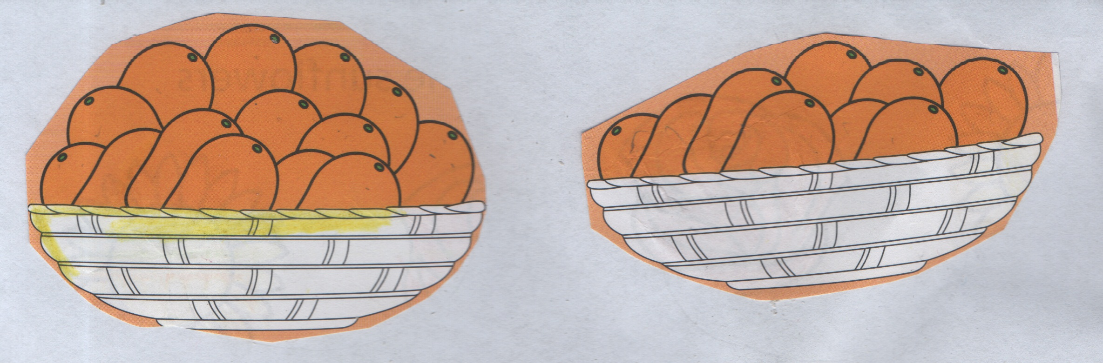

Q. 5. Oral counting 1 – 10 [ /5]

Army Public College
Chinar Campus Murree
SAMPLE PAPER – ENTRY TEST
Paper: English MARKS: 25
Class: PREP Time: 30 Minutes

Q. 1. Join to make words. [ /5]
c + a t = ___________

m + a t = ___________

f + a t = ___________

b + a t = ___________

r + a t = ___________

Q. 2. Write the next letters. [ /6]

D d G g

K k M m

Q q W w

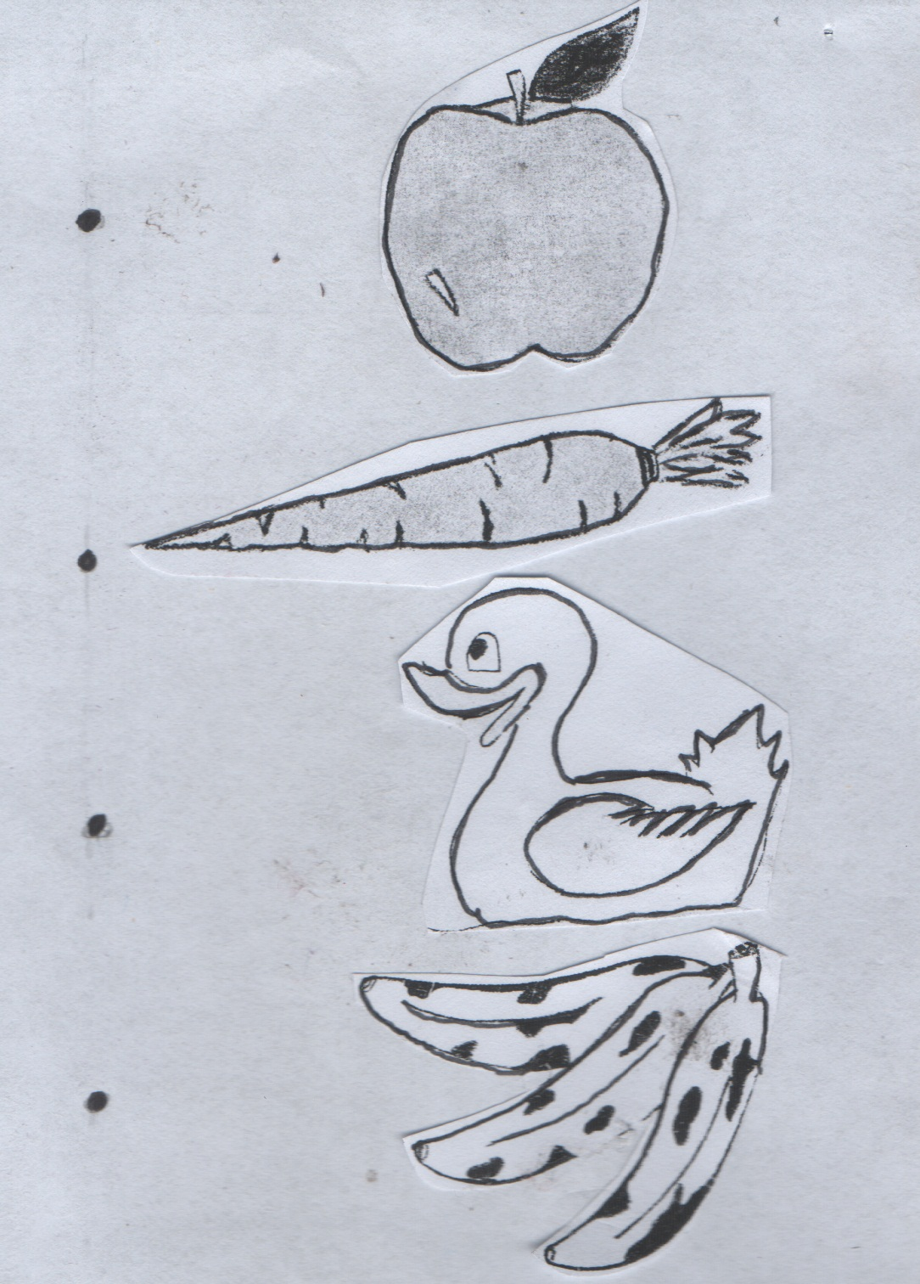
Q. 3. Match the letter to the picture. [ /5]
b

d

a

c

f

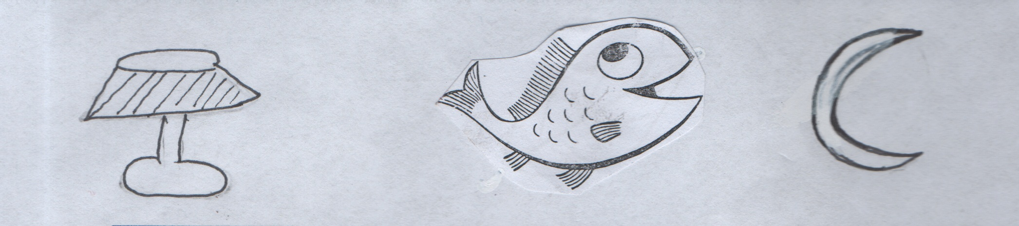
Q. 4. Write the first letter of the picture. [ /5]


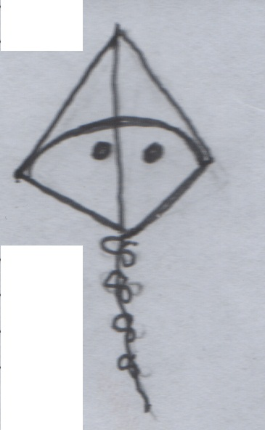

Q. 5. Reading. [ /4]
1) My name is Sam.
2) I am a girl / boy.
3) It is a pen.
4) This is a bin.
Army Public College
Chinar Campus Murree
SAMPLE PAPER – ENTRY TEST
Paper: Maths MARKS: 25
Class: PREP Time: 30 Minutes
Q. 1. Write the missing numbers. [ /10]
a. | 4 |  | 6 |  | 8

b. |  | 12 |  | 14 | 15

c. | 26 |  | 28 |  | 30

d. |  | 34 | 35 | 36

e. | 46 | 47 |  | 49

Q. 2. Count and write numbers. [ /5]

_________

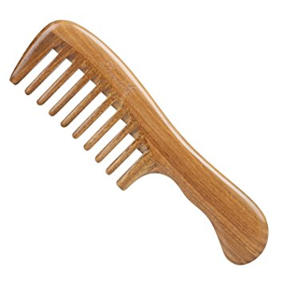
_________

_________

_________

_________

Q. 3. Write given numbers in words. [ /5]
1 _____________
2 _____________
3 _____________
4 _____________
5 _____________

Q. 4. Add the following numbers. [ /5]

5 3 6
+ 2 + 2 + 2

2 2
+ 2 + 1
Army Public College
Chinar Campus Murree
SAMPLE PAPER – ENTRY TEST
Paper: English Marks: 30
Class: I Time: 30 Minutes

Q. 1. Write plurals of these singulars. [ /5]
S. No. | Singular | Plural
i) | book
ii) | chair
iii) | boy
iv) | glass
v) | bag

Q. 2. Write the opposites. [ /5]
S. No. | Word | Opposites
i) | big
ii) | cold
iii) | stand
iv) | down
v) | night

Q. 3. Write the feminine of these masculine. [ /5]
S. No. | Masculine | Feminine
i) | uncle
ii) | grandfather
iii) | man
iv) | prince
v) | brother

Q. 4. Make sentences. [ /5]
S. No. | Word | Sentences
i) | tree
ii) | reading
iii) | flower
iv) | pencil
v) | cat

Q. 5. Look at the picture and write 5 things which you see in the picture. [ /5]
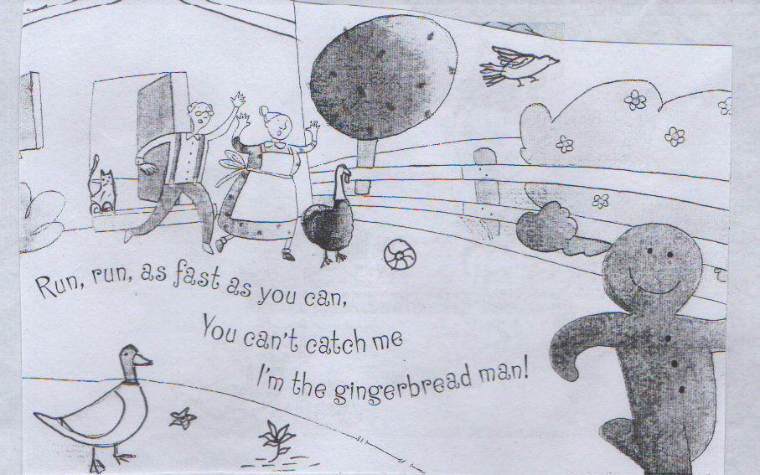

1) ______________________ 4) ______________________
2) ______________________ 5) ______________________
3) ______________________

Q. 6. Read the passage. [ /5]
At first the three little ducklings are happy. The second little duckling likes to fish. The third little duckling likes to sleep. They miss one another and Mommy duck. They pack their bags again and go home to the brick house in the forest.

Army Public College
Chinar Campus Murree
SAMPLE PAPER – ENTRY TEST
Paper: Maths Marks: 30
Class: I Time: 30 Minutes

Q. 1. Solve the following: [ /3]
a) 3, __________ 9, __________ ___________
b) 2, __________ 6, __________ ___________

Q. 2. Write counting in words. [ /5]
a) 10 __________________
b) 19 __________________
c) 35 __________________
d) 40 __________________
c) 26 __________________

Q. 3. Solve the following. [ /5]
a) 5 8 6 8 4
+ 5 + 0 + 2 + 3 + 3

b) Subtract: [ /5]
8 6 5 9 5
– 5 – 2 – 3 – 2 – 5

Q. 4. Fill in the missing numbers. [ /4]
30 ______ , ______ 33 ______ , ______ 36 ______ , ______
39 ______ , ______

Q. 5. Solve the following. [ /4]
a) 8 × 2 = 3 × 4 =
b) 9 × 3 = 3 × 10 =

Q. 6. Count the candles on each cake. Match with the correct number. [ /4]
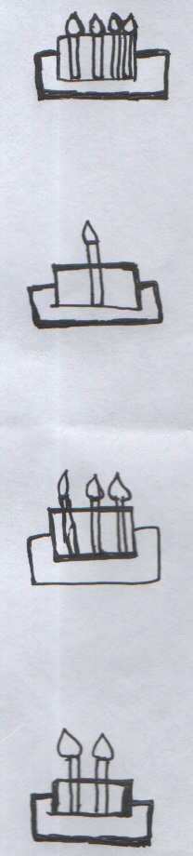
2

4

1

3

Army Public College
Chinar Campus Murree
SAMPLE PAPER – ENTRY TEST
Paper: English Marks: 30
Class: II Time: 30 Minutes
Q. 1. Read the passage carefully and answer the questions given at the end.
My family just adopted a puppy and a kitten from the animal shop. They were so young, they did not even have names yet. We had to think of good names of them.
My sister said, “Tomy for the Puppy and Mano for the kitten.”
We all thought those names were perfect.
(a) Fill in the blanks. [ /2]
The family adopted a _______________ and a ______________. They were
so _______________. We had to think of good _______________.
(b) Answer these questions. [ /3]
(1) What is the Puppy’s name going to be?
________________________________________________________________
(2) From where did they adopt the animals?
________________________________________________________________
________________________________________________________________
(3) Who thought the names were perfect?
________________________________________________________________
________________________________________________________________
Q. 2. Write opposites of given words. [ /5]
S. No. | Word | Opposites
i) | small
ii) | night
iii) | good
iv) | happy
v) | new

Q. 3. Make sentences of the following words. [ /5]
S. No. | Word | Sentences
i) | play
ii) | watch
iii) | house
iv) | drink
v) | box

Q. 4. Choose the correct words from the bracket and fill in the blanks. [ /5]

i) I __________________ a card. (made , maid)
ii) She saw a _______________ in the forest. (dear , deer)
iii) __________________ are many books on the shelf. (there , their)
iv) I _______________ you. (know , no)
v) The _____________ is blue. (see , sea)

Q. 5. Write 5 sentences about the topic. [ /5]

My Garden
_____________________________________________________________________
_____________________________________________________________________
_____________________________________________________________________
_____________________________________________________________________
_____________________________________________________________________
_____________________________________________________________________
_____________________________________________________________________

Q. 6. Read the given passage. [ /5]
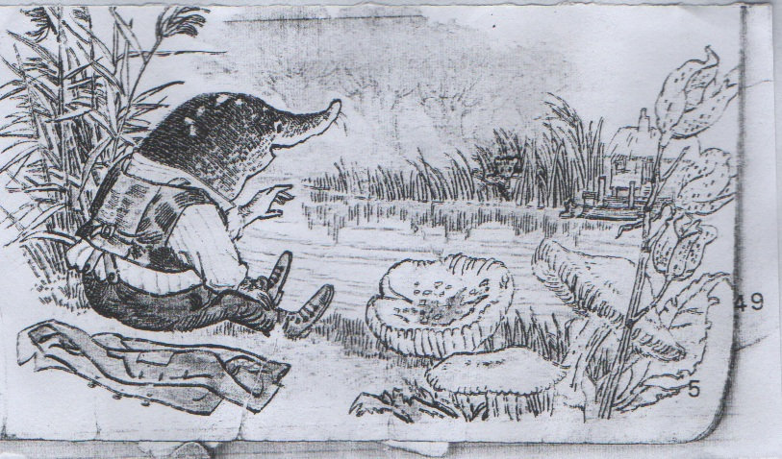
He sat down on the grassy bank and listened to the sound of the water. As he looked at the opposite bank, he saw a dark hole. Something bright and small twinkled in it. It winked, and he saw it was an eye! Then a small face appeared.

Army Public College
Chinar Campus Murree
SAMPLE PAPER – ENTRY TEST
Paper: Maths Marks: 30
Class: II Time: 30 Minutes
Q. 1. Write down names of shapes. [ /2]

_____________ _____________

_____________ _____________

Q. 2. Find the missing numbers. [ /2]
80
50

a)
32

36

40

b)

Q. 3. Add: [ /4]
a) T O T O
3 4 3 2
+ 6 5 + 5 0
___________ _________
b) T O T O
6 7 4 8
+ 2 1 + 0 1
___________ _________
Q. 4. Subtract: [ /4]
a) T O T O
3 6 7 9
– 2 4 – 3 4
___________ _________
b) T O T O
5 3 8 8
– 3 0 – 6 3
___________ _________
Q. 5. Multiply: [ /5]
a) 8 × 2 = ___________ f) 3 × 5 = ___________
b) 3 × 9 = ___________ g) 6 × 0 = ___________
c) 6 × 4 = ___________ h) 9 × 2 = ___________
d) 4 × 5 = ___________ i) 4 × 2 = ___________
e) 2 × 6 = ___________ j) 5 × 5 = ___________
Q. 6. Colour to show the fraction. [ /3]

= 2 .
6

= 1 .
3

= 2 .
4

Q. 7. Write counting in words. [ /5]
a) 27 _________________________
b) 29 _________________________
c) 34 _________________________
d) 54 _________________________
e) 69 _________________________
Q. 8. Write greatest to the smallest. [ /4]
84 54 99 60
______ ______ ______ ______

Q. 9. Tell the time. [ /1]

________ O’ Clock
Army Public College
Chinar Campus Murree
SAMPLE PAPER – ENTRY TEST
Paper: English Marks: 30
Class: III Time: 30 Minutes

Q. 1. Read the passage carefully and answer the questions given at the end. [ /10]
Peter and his grandfather lived in a house near a beautiful green meadow. Next to the meadow, there was a dark forest. In the middle of the forest, there lived a hungry wolf.
One day, grandfather said, “Peter, you must stay in the garden, you must never go into the meadow alone.” “But! why?” Said Peter. “Because there is a hungry wolf in the forest,” said grandfather and went out.
Peter looked over the garden wall. The meadow looked very beautiful. A little red bird flew up a tree. “Hello, Peter!” called the bird. “Why don’t you come into the meadow!” Peter climbed over the garden wall and went into the meadow. There was a pond in the middle of the meadow. A duck waddled past Peter and jumped into the pond.
A. Fill in the blanks. [ /5]
1. The meadow was ________________.
2. “You must _____________ in the garden,” said grandfather.
3. There was a ____________ in the middle of the meadow.
4. Peter lived with his _____________.
5. Peter climbed over the _______________ wall.
B. Answer these questions. [ /5]
Q. 1. Where was the forest? [1]
Ans: ______________________________________________________________
______________________________________________________________
Q. 2. Who called Peter to the meadow? [1]
Ans: ______________________________________________________________
______________________________________________________________
Q. 3. What did the duck do? [1]
Ans: ______________________________________________________________
______________________________________________________________
Q. 4. Why did grandfather tell Peter not to go to the meadow? [2]
Ans: ______________________________________________________________
______________________________________________________________
Q. 2. Complete the sentences. [ /4]
1. My favourite ____________________________________________.
2. I want to _______________________________________________.
3. I live __________________________________________________.
4. We are ________________________________________________.
Q. 3. a) Write opposite of these words. [ /2]
S. No. | Words | Opposites
i) | black
ii) | soft
iii) | sit
iv) | left

b) Write a rhyming word in each line. [ /3]
1. took , look , ____________
2. site , kite , ____________
3. three , free , ____________
Q. 4. Write a short paragraph on any one of the given topics. (6 sentences). [ /6]
a) My Favourite Cartoon Programme b) My Father
____________________________________________________________
____________________________________________________________
____________________________________________________________
____________________________________________________________
____________________________________________________________
____________________________________________________________
____________________________________________________________
____________________________________________________________
Q. 6. Read the given passage with correct pronunciation and fluency. [ /5]

Biff was in her bedroom reading a book. Kipper came in and they
sat on Biff’s new carpet. Kipper was learning to read and he wanted
to read to Biff.
Suddenly, the magic key began to glow.
Another adventure had begun. This time Biff and Kipper were on a
flying carpet.

Army Public College
Chinar Campus Murree
SAMPLE PAPER – ENTRY TEST
Paper: Maths Marks: 30
Class: III Time: 30 Minutes
Q. 1. What value does each digit in 635 stand for: [ /1.5]
8 6 0

Q. 2. Arranging the numbers from the greatest to the smallest. [ /2]
We have 325 , 997 , 125 , 682
_________ , _________ , _________ , _________
Q. 3. Circle the even numbers. [ /2]
80 47 8 113
41 2 26
Q. 4. Circle the smallest numbers. [ /2.5]
a) 625 _______ 893
b) 635 _______ 500
c) 810 _______ 820
d) 550 _______ 505
e) 611 _______ 601
Q. 5. Solve the following.
a) Add: [ /4]
7 5 9 6 3 6
+ 0 2 8 + 4 2 9
________________ ______________
b) Subtract [ /4]
9 7 3 9 7 2
− 4 3 8 − 5 0 9
________________ _______________
c) Multiply [ /4]
8 9 10 9
× 5 × 6 × 8 × 7
______ ______ _______ _______

d) Division [ /4.5]
35 ÷ 5 = _____ 36 ÷ 4 = _____ 6 × 5 = _____
15 ÷ 3 = _____ 54 ÷ 6 = _____ 7 × 5 = _____
6 × 9 = _____ 5 × 9 = _____ 3 × 6 = _____

Q. 6. Colour to show the correct fractions. [ /3]

a and make

3/9 6/9 1 whole
Q. 7. How many? [ /2.5]
a) 2 hours = _______________ minutes.
½ hour = _______________ minutes.
2 weeks = _______________ days.
b) Write the name of shapes.

= ____________ = _____________

APC, CHINAR CAMPUS MURREE
SAMPLE PAPER – ENTRY TEST

CLASS: 4th Time: 1 hour

Subject:: English Max Marks: 50
----------------------------------------------------------------------------------------------------------------------------------

Q No.1 Make sentences. 05
a. Large _________________________________________
_________________________________________
b. Sharp _________________________________________
_________________________________________
c. Excited _________________________________________
_________________________________________
d. Visit _________________________________________
_________________________________________
e. Creature _________________________________________

Q No.2 Circle the correct verb from the brackets. 05
a. My glasses (was / were) on the bed.
b. A pair of plain trousers (are / is) in the closet.
c. There (are / is ) so many trees in the forest.
d. The number of foreign cars (is / are) growing.
c. The students (are / is) attending the party.

Q No.3 Punctuate the following sentences with full stops, question marks, commas,
exclamation marks and capital letters. 05
a. why are you crying
__________________________________________________________
b wow what a nice dress
__________________________________________________________
c. after a week everything was normal
__________________________________________________________
d. my neighbour mr zahid is a thorough gentelman
__________________________________________________________
e. hurrah she’s here at last
__________________________________________________________

Q No.4 Complete the sentences with present tense of the verb given in the brackets. 05
a. The boy (run) _________________ fast.
b. The monkeys (to be) ______________ chattering in the trees.
c. It (have) __________________ rained heavily.
d. They (bump) ______________ into each other while playing.
c. Ali (write) ________________ a letter to his friend.

Q No.5 Fill in the blanks with the appropriate preposition. 05
a. They go to the Church ___________ Sunday.
b. The guests will arrive ______________ 7 O’ clock.
c. My mother sleeps ______________ the afternoon.
d. The cat is sleeping ___________ the chair.
e. The books are __________ the table.

Q No.6 Fill in the blanks with the Antonyms of the words in the brackets. 05
a. My father (forgot) _______________ my birthday.
b. At the (starting) _______________ of the ceremony we had a lavish lunch.
c. It was (easy) ________________ to know the answers of all questions.
d. Ali was (happy) _______________ on his birthday.
e. The teacher (agrees) _____________ to his statement.

Q No.7 Write a paragraph on any one of the following. 10
a. My Hobby
b. My School
c. My Best Friend

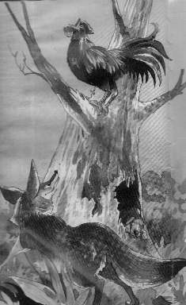
Q No.8 Write five sentences about the picture. 05

Q No.9 Read the sentences and underline nouns and adjectives. 05
a. The sly fox saw the hen.
b. Ali is friendly and kind.
c. We are looking for a good singer.
d. Your writing is very small.
APC, CHINAR CAMPUS MURREE
SAMPLE PAPER – ENTRY TEST
CLASS: 4th Time: 1 hour

Subject:: Mathematics Max Marks: 50
----------------------------------------------------------------------------------------------------------------------------------

Q No.1 a. Arrange these numbers in ascending order. [2.5+2.5]
2054 , 2009 , 2066 , 2030
__________________________________________________________
b.
4003 , 4001 , 4000 , 4006
__________________________________________________________
Q No.2 a. Arrange these numbers in descending order. [2.5+2.5]
7263 , 7242 , 7290 , 7265
__________________________________________________________
b.
8608 , 8691 , 8504 , 8890
__________________________________________________________

Q No.3 Write the missing numbers in the boxes. [2.5+2.5]

a. 5250 , , 5270 , 5280 ,

b. 7290 , , 7490 , 7590 ,

Q No.4 a. Find the sum of 9255 and 6150 [2.5+2.5]

b. Subtract 4506 from 9265

Q No.5 Add: [5+5]
a. 7 + 2
5 10

- Subtract:-

7 - 5
- 25

Q. No. 6 Mrs Saleem bought 7 boxes of biscuits. If each box contained 48 biscuits,
how many biscuits did she buy altogether? [05]

Q. No. 7 Farmer Jim has 1012 carrots. He puts them equally into 4 baskets.
How many carrots are there in each basket? [05]

Q. No. 8 The cost price of 9 books is 720. Find the cost price of 3 such books. [05]

Q. No. 9 Write in minutes [05]
(i) 5 h 40 min __________ (iv) 1 h 10 min __________
(ii) 2 h 35 min __________ (v) 8 h 15 min __________
(iii) 6 h 20 min __________

APC, CHINAR CAMPUS MURREE
SAMPLE PAPER – ENTRY TEST
CLASS: 5th Time: 1 hour

Subject:: English Max Marks: 50
----------------------------------------------------------------------------------------------------------------------------------

Q No.1 Make sentences. 05
a. careful ________________________________________________
________________________________________________
b. forest ________________________________________________
________________________________________________
c. catch ________________________________________________
________________________________________________
d. wise ________________________________________________
________________________________________________
e. protected ________________________________________________
________________________________________________

Q No.2 Put punctuation marks. 05
a. do you know about the event
b. when will be your party
c. Hurrah I have won the prize
d. the baby slept peacefully
f. they were excited for their success

Q No.3 Write the past tense of these verbs. 05
a. Nobody ______________ to buy shoes from this shop. (like)
b. African animals ______________ giants in the animal kingdom. (are)
c. They ______________ their favourite cartoon. (watch)
d. We _____________ to our grandparent’s house last week. (go)
e. He _______________ on his bed. (jump)

Q No.4 Write proper words from the brackets. 05
a. All the friends decided ____________ (have) a trip. (to , two)
b. The children painted the wall ___________ five hours. (within , with in)
c. I have ___________ a story. (red , read)
d. The boy _____________ best about the recent event. (knows , nose)
e. They were afraid __________ darkness. (of , off)

Q No.5 Add a prefix or suffix to complete each sentence. 05
a. This bed is __________________ for the kids. (comfort)
b. The boy felt ______________ when his mother was outside. (happy)
c. The teacher _______________ with Ali’s answer. (agrees)
d. My mother is very _______________ (respect)
e. These items are _________________ for the students. (necessary)

Q No.6 Define the following with two examples for each. 05
Pronoun: _____________________________________________________
_____________________________________________________
_____________________________________________________
Simile: __________________________________________________________
_____________________________________________________
_____________________________________________________

Q No.7 Write a paragraph on any one of the following topics. 10
a. My Favourite Personality b. My Book c. My Pet

Q No.8 Write a letter to your friend telling him/her about your birthday party. 10

…………………….
APC, CHINAR CAMPUS MURREE
SAMPLE PAPER – ENTRY TEST
CLASS: 5th Time: 1 hour

Subject:: Mathematics Max Marks: 50
-----------------------------------------------------------------------------------------------------------------------------------

Q No.1 Write the following in numerals [05]
a. Eighty-nine thousand five hundred and five _____________
b. Sixty seven thousand six hundred and forty two _____________

Q No.2 Write the following in words. (1.5+1.5+2) = [05]
a. 63970 _______________________________________________
b. 52905 _______________________________________________
c. Express improper fraction number 10 in its mixed form.
8

Q No.3 Arrange in ascending order. [05]
a. 40 040 , 44 004 , 40 440
_________________________________________________________
b. 65 710 , 49 820 , 62 090 , 82 350
_________________________________________________________

Q No.4 Arrange in descending order. [05]
a. 10 207 , 10 027 , 10 702
_________________________________________________________
b. 39 287 , 39 187 , 39 887
_________________________________________________________

Q No.5 Compare the following numbers. [05]
94322 38564 (02)

62478 65319 (02)

45015 45020 (01)

Q No.6 Solve the following.. [06]

a. 1 + 2 b. 7 – 1 c. 5 x 3
14 7 8 4 6 10

Q No. 7 Express the following into fractions and simplify. [04]

a. 0.35
b. 0.629
c. 4.26
d. 8.05

Q No.8 Convert the following. [05]
a. 5 hours = minutes.
b. The train arrived at Lahore station at 09:45. It was one hour and
seven minutes late. What was the original time of arrival?

Q. No.9 In a week, Mr. Waseem baked 1789 cakes and twice as many cream puffs.
How many cakes and cream puffs did he bake altogether in that week? [05]

Q. No.10 3596 books will be shared equally by 6 school libraries.
How many books will each library get? How many books will be left? [05]

APC, CHINAR CAMPUS MURREE
SAMPLE PAPER – ENTRY TEST
CLASS: 6th Time: 1 hour

Subject:: English Max Marks: 50
-----------------------------------------------------------------------------------------------------------------------------------

Q No.1 Use the following words in suitable sentences. 05
a. ambitious ______________________________________________________
______________________________________________________
b. probably ______________________________________________________
______________________________________________________
c. playmate ______________________________________________________
______________________________________________________
d. congratulate ______________________________________________________
______________________________________________________
e. ashamed ______________________________________________________
______________________________________________________

Q No.2 Fill in these blanks by using present perfect tense. 05
a. She ____________ (finish) her meal.
b. They ____________ (come) to school.
c. ____________ (have) you __________ (complete) your homework?
d. They ______________ (play) the Football.
e. He _______________ (read) the novel.

Q No.3 Fill in the blanks by using present continuous tense. 05
a. I ______________ (write) a letter.
b. We ____________ (play) cricket.
c. She ____________ (washing) her clothes.
d. You ________________ (sleep)
e. The ______________ (go) to market for shopping.

Q No.4 Translate into English. 05
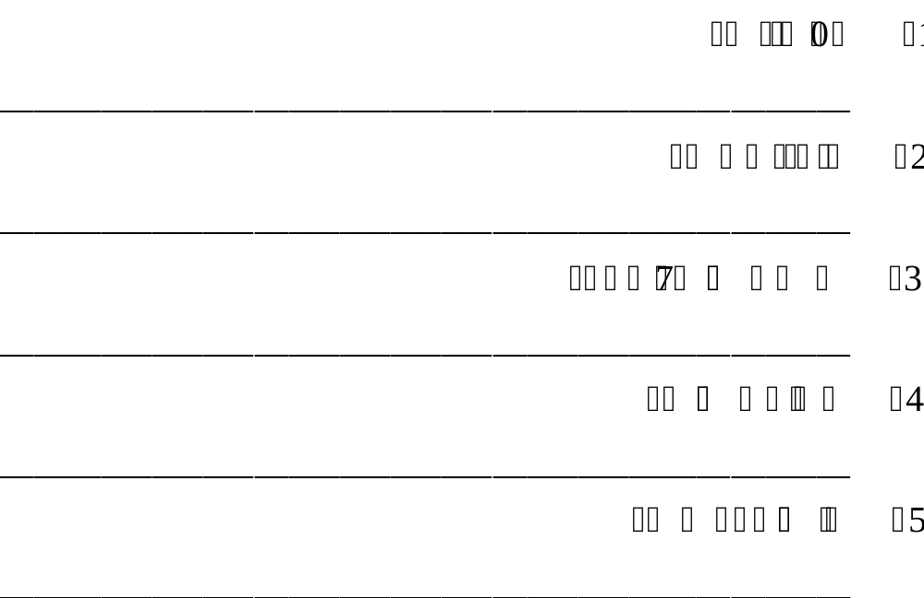

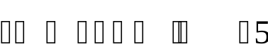

Q No.5 Write a letter to your friend inviting him/her to spend his/her winter holidays
with you in Murree 15

Q No.6 Write a paragraph on any one of the following topics. (150 – 200 words) 15
a. My Favourite Personality
b. My Last Day at School
c. My Favourite Game

…………………
APC, CHINAR CAMPUS MURREE
SAMPLE PAPER – ENTRY TEST
CLASS: 6th Time: 1 hour

Subject:: Mathematics Max Marks: 50
----------------------------------------------------------------------------------------------------------------------------------
Attempt all question:

Q No.1 Separate prime and composite numbers 23, 35, 42, 49, 101 [05]
Q No.2 What does each digit stand for in the number 27085 [05]
2 7 0 8 5

Q No.3 Find the LCM and HCF of 36 and 48 [05]
Q No.4 Simplify: [05]
i) 12.6 ÷ 200 ii) 0.067 × 1000
Q No.5 i) Convert 4350 g to Kg. [05]
ii) Convert 3780 cm to m
Q No.6 Simplify [05]
1 + 2 ÷ 3 + 2
5 7 10 5
Q No.7 There were 500 students in school 230 students are boys.
Find the percentage of boys in school. [05]
Q No.8 Find the simplest ratios. [05]
i) 30 : 45 ii) 12 : 18
Q No.9 Define the following triangles: [05]
i) Scalene triangle ii) Isosceles triangle iii) Equilateral triangle
Q No.10 Find the unknown angle. A [05]
50

55
C B
APC, CHINAR CAMPUS MURREE
SAMPLE PAPER – ENTRY TEST
CLASS: 7th Time: 1 hour
Subject:: English Max Marks: 50
----------------------------------------------------------------------------------------------------------------------------------
Q No.1 Complete the sentences by using correct helping verbs. [2.5]
i. They ______________________ eaten up all the food.
ii. Students __________________ not talk while the teacher is teaching.
iii. How many pupils _________________ absent today?
iv. The heavy rain __________________ flooded many parts of the Island.
v. I __________________ put the keys in the box.
Q No.2 Convert the sentences into questions. [05]
i. Julian performed his duty well.
____________________________________________________________________
ii. Tess was praised by his teacher.
____________________________________________________________________
iii. I did the exercise.
____________________________________________________________________
iv. The earth revolves round the sun.
____________________________________________________________________
v. Usman eats fish for breakfast.
____________________________________________________________________
Q No.3 Write whether the two underlined words in each sentence are
Synonyms or Antonyms. [2.5]
i. Ali is much calm than his hyper brother Umar. ____________________________.
ii. His foolish acts made him the silly person of the family. _____________________.
iii. Failure is a very serious step towards success. _____________________________.
iv. The teacher asked the answer but Sara didn’t reply. __________________________.
v. To begin work on the computer, we need to start it by pressing the button.
_______________________________.
Q No.4 Make meaningful sentences of the following words. [05]
i. fashion : _________________________________________________________
____________________________________________________________________
ii. weather : _________________________________________________________
____________________________________________________________________
iii. difficult : _________________________________________________________
____________________________________________________________________
iv. mysterious : _________________________________________________________
____________________________________________________________________
v. arrive : _________________________________________________________
____________________________________________________________________

Q No.5 Punctuate the following. [05]
there was a severe storm last night peter told us the final match was delayed
due to rain it will be played next monday everyone was curious to watch it the
weather will be sunny next week.
___________________________________________________________________
___________________________________________________________________
___________________________________________________________________
___________________________________________________________________
___________________________________________________________________
___________________________________________________________________
___________________________________________________________________

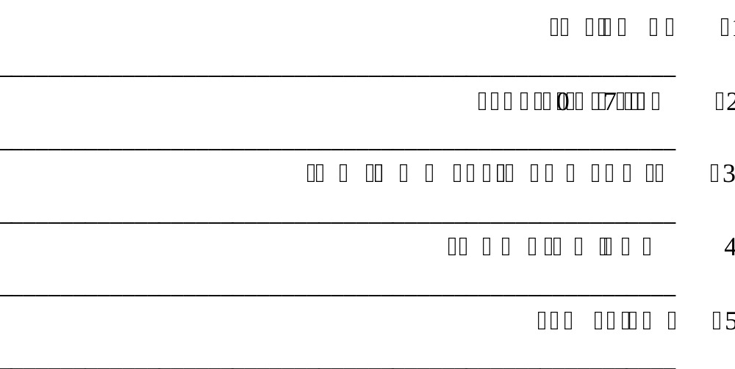
Q No.6 Translate the following sentences into English. [05]

Q No.7 Look around your classroom where you are sitting and write five sentences
using nouns and adjectives. [05]
i. ____________________________________________________________________
ii. ____________________________________________________________________
iii. ____________________________________________________________________
iv. ____________________________________________________________________
v. ____________________________________________________________________
Q No.9 Write a letter to your friend about the profession you wish to adopt. [10]

Q No.10 Write an essay between 100 to 150 words on any one of the following topics. [10]
a. Benefits of book reading
b. My School Library
c. The weather I like the most.
APC, CHINAR CAMPUS MURREE
SAMPLE PAPER – ENTRY TEST
CLASS: 7th Time: 1 hour

Subject:: Mathematics Max Marks: 50
----------------------------------------------------------------------------------------------------------------------------------

Q No.1 Find LCM and HCF of [05]
a. 15 , 60 and 75

Q No.2 Find the value of: [05]
15 × 3 1 + – 1
10 –
÷ 4
8 2 2 4

Q No.3 The length of side of square is 10 m. Find [05]
a. The area of square

b. The perimeter of square

Q No.4 a. If x = 5 and y = – 3 then evaluate 3 x + 4y [3+2]
5
b. Simplify 6xy + 13x – 2xy – 5x

Q No.5 Solve 2y – 3 = 2y + 5 [05]
3 4 8

Q No.6 a. Express the fraction as a percentage 12 [5+5]
25
b. Express the decimal as a percentage 1.35

Q No.7 Given that 2x = 3y , find the ratio of x : y [05]
5 8

Q No.8 If x : y = 11 : 8 and y : z = 6 : 7 , calculate x : y : z [05]

Q No.9 A car requires 22 litres of petrol to travel a distance of 259.6 Km. [05]
Find the distance that the car can travel on 63 litres of petrol.

APC, CHINAR CAMPUS MURREE
SAMPLE PAPER – ENTRY TEST
CLASS: 8th Time: 1 hour

Subject:: English Max Marks: 50
-----------------------------------------------------------------------------------------------------------------------------------

Q No.1 Use the following words in meaningful sentences. 05
a. accurate ______________________________________________________
______________________________________________________
b. chase ______________________________________________________
______________________________________________________
c. prefer ______________________________________________________
______________________________________________________
d. celebrate ______________________________________________________
______________________________________________________
e. extreme ______________________________________________________
______________________________________________________

Q No.2 Fill in the blanks with correct preposition. 05
a. We live ___________ London.
b. Would you like to go _________ the cinema?
c. We are going ___________ holidays.
d. There is a bridge _____________ the river.
e. Who is the person ___________ this picture?

Q No.3 Change the voice accordingly. 05
a. Open the door.
_________________________________________________________
b. She is going to buy a new bike tomorrow.
_________________________________________________________
c. They wrote a letter yesterday.
_________________________________________________________
d. She has already played this game.
_________________________________________________________
e. She eats mangoes.
_________________________________________________________

Q No.4 Choose the verb that agrees with the subject. 05
a. She (like , likes) to eat mangoes.
b. They (are , is) making a lot of noise.
c. We (celebrate , celebrates) this event every year.
d. The report was (made , make) by Ali.
e. They (chase , chases) the deer everyday.

Q No.5 Fill in the blank with future perfect tense. 05
a. They ______________ (finish) their work.
b. I _______________ (take) my meal by 11 O’ clock.
c. My friend _______________ (buy) a new car by next year.
d. She _____________ (learn) English.
e. My mother _____________ (cook) delicious dishes.

Q No.7 Translate the following sentences. 05
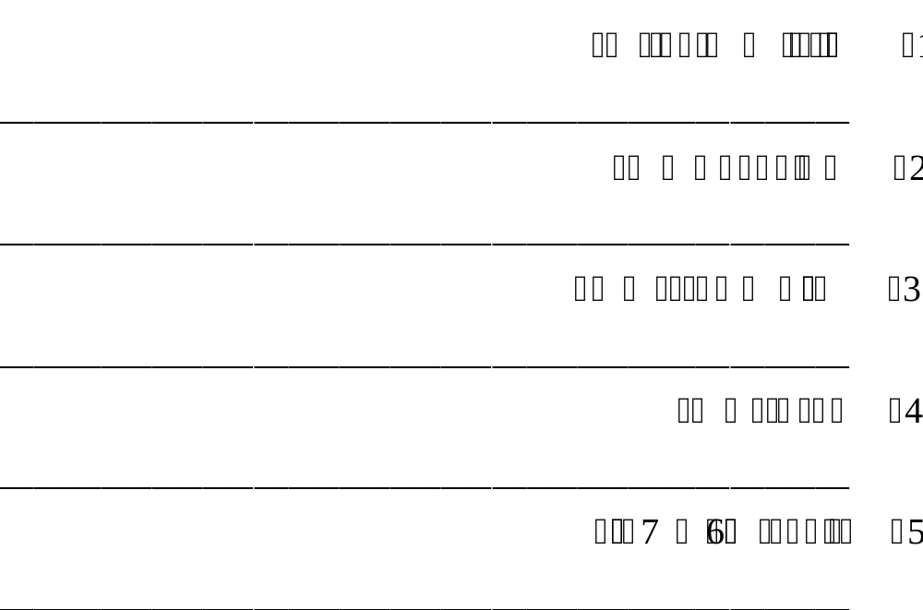

Q No.8 Write a paragraph on any one of the following topics: 10
a. My aim in life
b. Impact of Social Media

Q No.9 Write a letter to your friend to invite him to your city in vacations. 10

APC, CHINAR CAMPUS MURREE
SAMPLE PAPER – ENTRY TEST
CLASS: 8th Time: 1 hour

Subject:: Mathematics Max Marks: 50
-----------------------------------------------------------------------------------------------------------------------------------
NOTE: Attempt all questions.

Q No.1 (a) If: (5+5)
U = { x/x is a positive integer less than 16 }

A = { x/x is a multiple of 4 }

B = { x/x is a factor of 8 } Then find (A∩B)^{C}

(b) If area of rectangle is 112 cm² and its base = 14 cm, find its height

Q No.2 (a) Expand the following expression ( 2 x – y) ( 3 x + 2 y + 1 ) (5+5)

(b) Find two consecutive positive even numbers such that the sum of
their square is 164.

Q No.3 (a) Solve the following equation x² – 3 x – 28 = 0 (5+5)

(b) Simplify a – 2 b ÷ 4 a – 8 b
16 24

Q No.4 (a) Add the following fraction (5+5)
7 4 .
+
2 x– 5 x–3

(b) 10 identical taps can fill a tank in 4 hours. Calculate the time taken
for 8 such taps to fill the same tank.

Q No.5 (a) Solve the following equation. (5+5)

3m –1 – 2m – 3 = 1
5 3

(b) A ladder of length 5 cm is placed against a vertical wall with its foot 1.8 m
away from the base of the wall. How far up the wall does the ladder reach?

…………………………………..……….

Army Public College
Chinar Campus Murree

SAMPLE PAPER – ENTRY TEST

Paper: English Marks: 50
Class: IX Time: 1 Hr
Q. 1. (a) Fill in the blanks with suitable prepositions. [05]
(i) They were not aware _____________ my difficulties.
(ii) He was born _____________ a rich family.
(iii) This angle is equal ______________ that.
(iv) The sun rises _________________ the East.
(v) You must act ___________ the advice of your teacher.
(b) Match the words from list ‘A’ with their similar meaning in list ‘B’. [05]
List A List B
(i) Swift Living example
(ii) Determined Proselytizing
(iii) Embodiment Quick
(iv) Preach Resolute
(v) Obtain Gain
(c) Use correct form of verb. [05]
(i) He (go) to school every day. (ii) They (playing) a match.
(iii) I (not take) my meals at night. (iv) She (work) well yesterday
(v) They (playing) cards for six hours.
(d) Change the voice. [05]
(i) She will not lend me the book. (ii) They are writing a story.
(iii) I did not know him. (iv) You were reading novels.
(v) He sold newspaper for living.
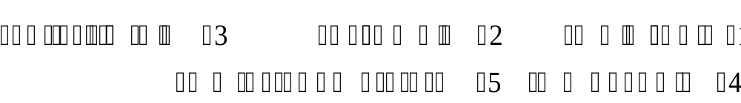
Q. 2. (a) Translate the given sentences into English. [05]

(b) Translate in to Urdu. [05]
(i) How tall were those trees?
(ii) We are printing a new book.
(iii) Pakistan is making progress by leaps and bounds.
(iv) The student has been working hard for four months.
(v) You will accept the invitation of your friend.
Q. 3. Write a paragraph of 150 words on any one of the following: [10]
(a) My Favourite Book (b) Big City Problems (c) Women Empowerment
Q. 2. Write a letter to your friend condoling him/her the death of his/her mother. [10]

Army Public College
Chinar Campus Murree

SAMPLE PAPER – ENTRY TEST
Paper: Maths Marks: 50
Class: IX Time: 1 Hr

Note:- Attempt any ten questions. All questions carry equal marks.
Q. No. 1. Use laws of exponent to simplify:
( 2 x⁵ y⁻⁴ ) (- 8 x⁻³ y²)
Q. No. 2. Find the square root of 27896 by division method and show the working.
Q. No. 3. If U = N, A = {1, 3, 5, 7, 9} , B = {0, 2, 4, 6, 8, 10} then prove any one De Morgan’s Law.
Q. No. 4. If A = 1 2 , B = 3 - 1 then find the value of (AB)⁻¹
4 6 2 - 2

Q. No. 5. Find the solution set of 2 x + 5 y = –1 and x – 2 y = 4
Q. No. 6. If x = 5 – 2 , find x + 1/x
Q. No. 7. Factorize 11 ( a + b)² – 99 c²
Q. No. 8. Factorize x² + 14 x + 49
Q. No. 9. a) Evaluate (– i )⁸
b) Write the real and imaginary part of (1 + i)
Q. No. 10. Find the value of x in the given right triangle.
13
x
5
Q. No. 11. Aslam wants to construct a fence around a square plot of area 24778 m².
Find the cost of construction if cost of fence is Rs. 25. per meter.
Q. No. 12. Draw a triangle having angles of measure 60º and 30º and measure of
included side is 5 cm.



